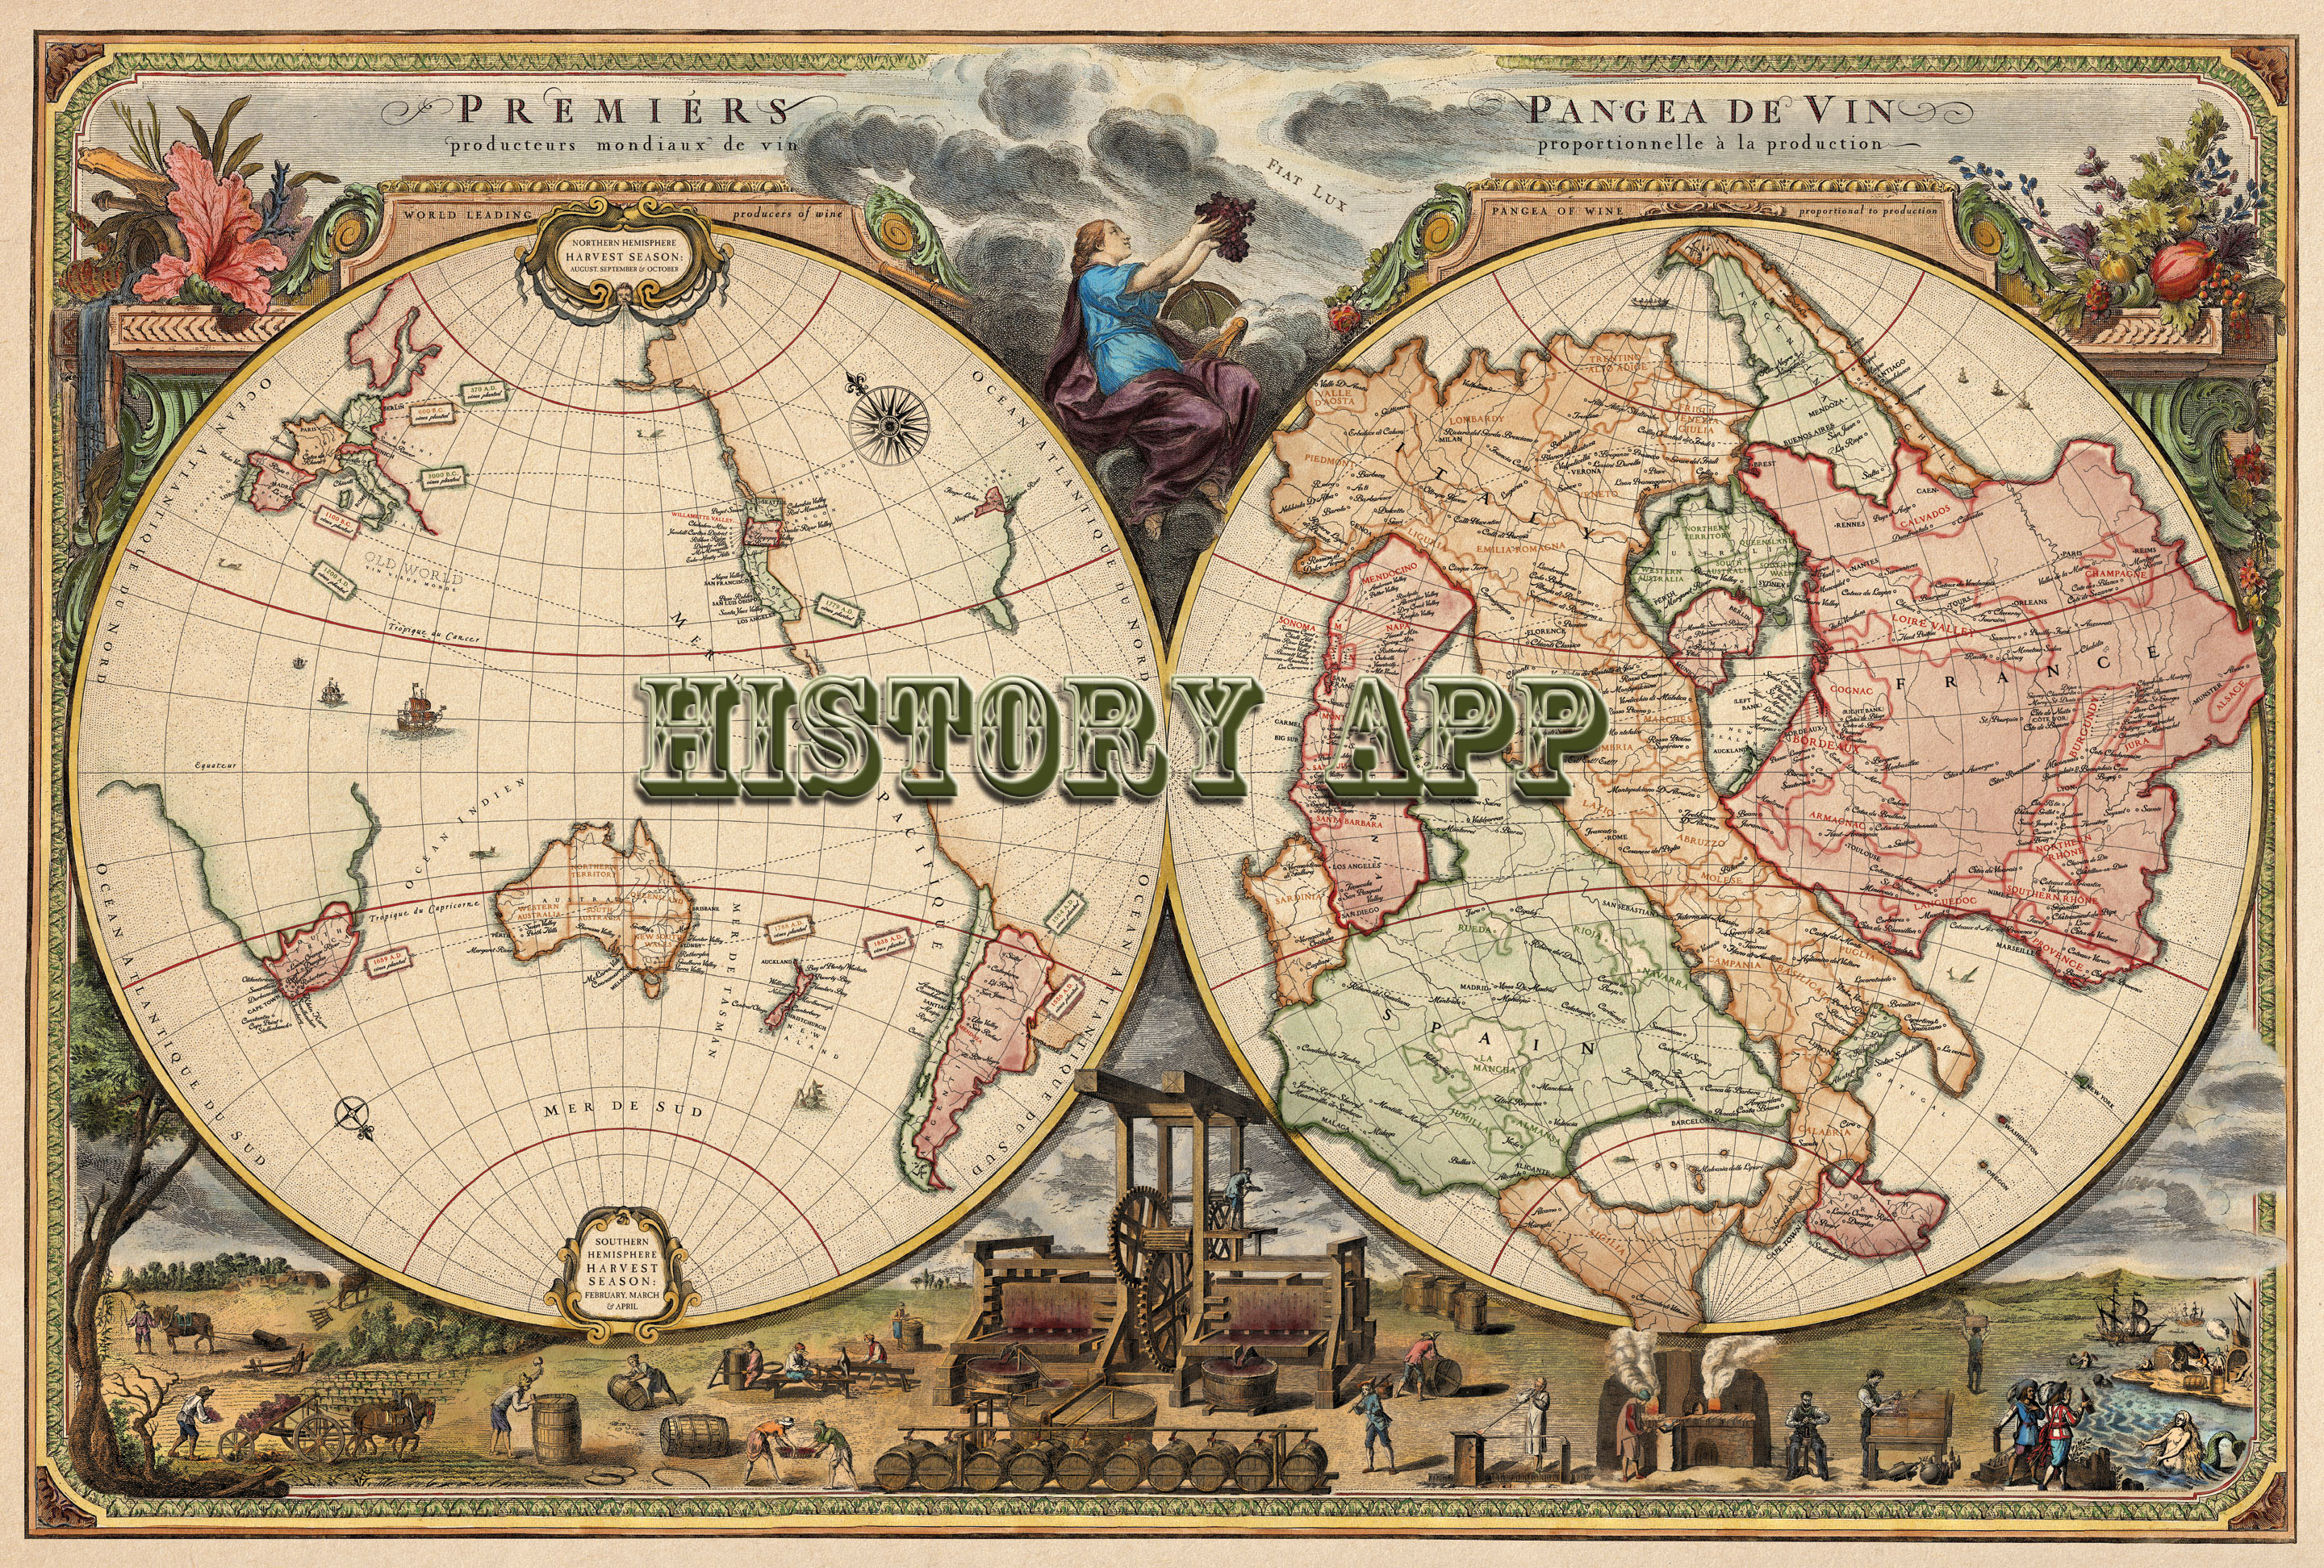

rEQUIREMENT dOCUMENT
Florida International University
Senior Project
CIS 4911
9/8/2014

Mentor:
Tracy Beeson

Development Team:
Ariel Diaz
Yesenia Yser

Copyright and Trademark Notices

I have carefully assessed the Software Requirement Document for the History App. This document has been completed in accordance with the requirements of the FIU System Development Methodology.

All materials available on this document are protected by copyright laws and international copyright treaty provisions. This material has been placed on this Internet site under the authority of the copyright owner for the sole purpose of viewing of the materials by users of this site. Users are not authorized to download or transmit any of these materials electronically, or to otherwise reproduce any of the materials in any form or by any means, electronic or mechanical, including data storage and retrieval systems, recording, printing or photocopying.
© 2014 FLORIDA INTERNATIONAL UNIVERSITY. ALL RIGHTS RESERVED

We fully accept the changes as needed improvements and authorize initiation of work to proceed. Based on our authority and judgment, the continued operation of this system is authorized.

_______________________________ _____________________
NAME DATE
Project Leader

_______________________________ _____________________
NAME DATE
Operations Division Director

_______________________________ _____________________
NAME DATE
Program Sponsor Representative

_______________________________ _____________________
NAME DATE
Program Area/Sponsor Director

Abstract

This document contains the software requirements for the History Map system. This project is one out of 18 Senior Projects for Fall 2014 at Florida International University.

These software requirements were established according to requests from the mentor, Tracy Beeson, and her passion for History. The system to be developed is for tourist and adventurers to route a historical virtual tour at a certain GPS coordinate, address, or city. This document follows the IEEE standard for a requirements specification document, with some variations.
Software Requirement Document

TABLE OF CONTENTS

Page #

1.0 INTRODUCTION
1.1 Problem Defintion
1.2 Scope
1.3 Definition, Acronyms and Abbreviations
1.4 Overview of Document 1-2
2.0 CURRENT SYSTEM
3.0 PROJECT PLAN
3.1 Project Organization
3.2 Work Breakdown 3-2
3.3 Cost 3-2
4.0 PROPOSED SYSTEM REQUIREMENTS 4-1
3.1 Functional Requirements 4-1
3.2 Analysis of System Requirements 4-1
3.2.1 Senarios 4-1
3.2.2 Use Case Model 4-1
3.2.3 Static Model 4-1
3.2.1 Dynamic Model 4-1
5.0 GLOSSARY 5-1
6.0 APPENDIX 6-1
6.1 Appendix A -- Use Cases
6-1
6.2 Appendix B – Use Case Diagrams 6-1
6.3 Appendix C – Static UML Diagram 6-1
6.4 Appendix D – Dynamic UML Diagram 6-1
6.5 Appendix E – User Interface Designs 6-1
6.6 Appendix F – Diary of meeting and tasks 6-1
7.0 REFERENCES 7-1

Introduction

Chapter 1: Introduction
History Map connects you with the past. It provides accounts of historical places and events while making it accessible at the palm of your hand. This application gets its content from the vast knowledge of many historians and their years of experience in the field. You will be able to see a map showing all of the historical places of interest around you and History Map will show you the exact address of the place, hours of operation, and phone number. It will also present you with peer-reviewed files that elaborate on the history of the place. This Android application grants you access with an archive of audio, images and documents that have been peer reviewed by professionals. History Map allows you to take a tour through your city while giving you detailed accounts of the events that once happened where you’re standing!

1.1 Problem Definition
Many systems in today’s application market provide users with an array of features for travel, such as recommended sightseeing locations, user reviews on hotels and restaurants. However there is a gap in the market for documentation on historical events and places. History Map solves this problem by giving users a connection to history in a modern and accessible way. It grants access to audio, image and document files that explain historical events in detail.

1.2 Scope
History Map will provide a collaborative database of historical sites for Historical Societies, History scholars and researchers, as well as tourists. This project will allow a user to receive information regarding nearby historical sites denoted by markers when they input a GPS coordinate or an address in their Android mobile device. Users will be able to create or access a route generated for them, which they can drive or walk by. Users have access to audio files, peer-reviewed documents, and images to learn about this site.
Information for this application will be inputted by the site admin via a Web application. To input data, the user will type in a GPS coordinate or an address and receive auto filled information and may attach a media or document file to this location. Also, the admin will have a Tasks page for organizing the work to be done.
For future development, the application will allow users to upload their own content, provide feedback, and peer review. Add on content will be emailed to the admin, who will then review the data for accuracy and either send it back to be reworked on or publish it. This application will also be developed for the iOS users and different levels of subscription will be created for users who wish to download the published document files.

1.3 Terminology
For more definitions, please see the Glossary.
iOS - is a mobile operating system developed by Apple Inc. and distributed exclusively for Apple hardware.
Android - Android is a mobile operating system (OS) based on the Linux kernel and currently developed by Google.
Web Application - is any application software that runs in a web browser and is created in a browser-supported programming language (such as the combination of JavaScript, HTML and CSS) and relies on a web browser to render the application.
Database - a comprehensive collection of related data organized for convenient access, generally in a computer.
Admin - Application content administrator.
History Map Screen - Map showing nearby historical places.
Historical Place of Interest - Place with a Map Marker on the History Map Screen.
Historical Tour - Route from place A to place B which displays Historical Places of Interest along the path.
Peer-reviewed documents - Documents that have been reviewed by history scholars.
Drafted Item - a preliminary version of a piece of writing, audio or image that is sent over to the Admin to be published.
Published Item - a finished version of a piece of writing, audio or image that was approved by the Admin and is accessible by the users.
Map Marker - A visual element that is used to mark a map point within a map.
Geolocation - the process or technique of identifying the geographical location of a person or device by means of digital information processed via the Internet.
Global Positioning System (GPS) - is a space-based satellite navigation system that provides location and time information in all weather conditions, anywhere on or near the Earth where there is an unobstructed line of sight to four or more GPS satellites.
Responsive Design - a web design approach aimed at crafting sites to provide an optimal viewing experience—easy reading and navigation with a minimum of resizing, panning, and scrolling—across a wide range of devices (from mobile phones to desktop computer monitors).

Navigation systems - A GPS-based electronic system in a car or truck that provides a real-time map of the vehicle's current location as well as step-by-step directions to a requested destination.

1.4 Overview of Document
The next chapters of this document contain current functional and nonfunctional requirements for the History Map application. Chapter 2 describes the current system with its limitation and issues. Chapter 3 presents the overall project, including the team organization, work breakdown, and the estimated cost for this project. Chapter 4 introduces the proposed system including functional and nonfunctional requirements, including use case, sequence diagrams, and UML diagrams.
Chapter 5 contains a glossary of terminology used throughout the document. Appendix A contains the current domain of use case for the project. Appendix B contains the Use case diagram based on the Use Cases going to be implemented.. Appendix C contains the static UML diagram, while Appendix D contains the Dynamic UML Diagram. Appendix E displays the current mockup for the applications interface ideas. Appendix F holds meeting minutes and task assigned from the beginning of the project. Chapter 7 includes any references used to complete this project.

Current System

Chapter 2: Current systems
This chapter will discuss current systems similar to History Map.
2.1 Description of Current System
Navigation systems routes a user with their current GPS location to a destination. In the user interface, an address is inputted and the device will identify, with the map, different routes for the user to take to reach the destination. Constantly tracking their GPS location, it will navigate the route depending on the user’s preference, quickest route, avoid traffic, avoid highways, etc. New models of navigation system introduce current traffic, construction, detours, and accidents. Restaurant, gas stations and auto repairs are also included and searchable via a navigation device.
These navigation systems are the building blocks of the History Map project. While they include directions, business information, hours of operations, and locations, they lack in providing educational and historical information about the location. To learn more about the history of a building, site, architecture, art, etc, a user will have to use a different device or application and research this information on their own. Now a days, most of the information placed online is not verified for accuracy, so users have to be wary of which data they consider to be accurate or not. History Map will have researched knowledge base from current historical societies, museums, researchers, and scholars.

PROJECT PLAN

Chapter 3: Project Plan
This chapter provides a detailed account of how the project will proceed, including Gantt charts, hardware requirements, and role specification. The Project Organization specifies the role assignments for each project member. Hardware and Software Requirements specify the necessary requisites to implement and operate the History Map mobile application as well as the development environment. Finally, the work breakdown utilizes these small increments to schedule the deliverables, milestones, and tasks along with their dependencies.
3.1 Project Organization
The following table displays how the roles are broken down for the current deliverable of the project.

3.1.1 Project Personnel Organization
Table 3.1.1.1 demonstrates the current project organization. Each Individual is the project manager for the other, while fulfilling functional project roles.

Team Member | Roles
Yesenia Yser | Project Manager, Functional Analyst
Ariel Diaz | Project Manager, UI Designer
Table 3.1.1.1 Project Organization

3.1.2 Hardware and Software Resources
Trello: Each individual is granted access to the Senior Project’s Trello account to organize the software development process and to identify the projects current state.
Github: Each individual is granted access to the Senior Project’s project repository to have one centralized location to coordinate on the development.
StarUML: For the creation of UML diagrams, use cases, and sequence diagrams.
Android Studio: For the development of the Android application and as well as testing and emulation of the device
Google drive: Each individual is granted access to a shared Senior Project folder, which holds documentation, presentations, UML diagrams, images, and project associated data is kept.
Google hangouts: a video chat method to communicate ideas and discuss current project status and assign task.
Webcam and microphone: Used during the google hangouts video chats and provides ease of communication
Dropbox: Each individual is granted access to a shared Senior Project folder, which holds the final draft of the documents and presentations due to formatting issues with Google Drive.
Android phone: Meant for testing purposes.
PC: Windows 7 or 8, Mac OSX, minimum of 4GB of RAM, 10GB of hard drive memory space, and minimum of 1.86GHz pc spec
Microsoft Office Suite 2010/2013: For the creation, modification, and reviewing documents and presentations.
Microsoft Project 2013: For the creation, modification and reviewing Project scheduling documents, such as GANTT Charts.
IE/Firefox/Chrome: Used to access the course, and testing the web application
Gmail: For the creation of GitHub, Trello, google drive, and drop box account, as well as communication between partners, mentor and professor.
3.2 Identification of Tasks, Milestones, and Deliverables
The project schedule created displays the goals we accomplished from Sept 1 to Sept 8, 2014. The project schedule also displays goals we wish to accomplish by the next iteration phase. See Figure 3.2.1 for detailed Gantt Chart of History Map’s Project Schedule.

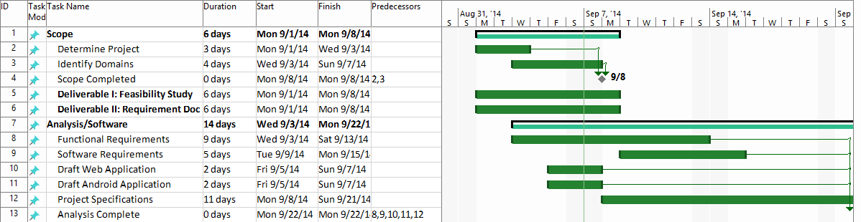
Figure 3.2.1 Detailed Project Schedule for First Draft
3.3 Cost

PROPOSED SYSTEM REQUIREMENT

Introduce the chapter (one or two paragraphs)
  - Functional Requirements – describes high-level functionality
Use the following format:
The system shall …
For each functional requirement state the associated non-functional requirements, if any, for Usability, Reliability, Performance, and Supportability.
  - Analysis of System Requirements
Analysis models – contains the complete functional specification and is mainly for the designers and programmers. This section describes the diagrams in the Appendices B - D and validates the models against the use cases.
    - Scenarios
    - Use case model
    - Static model e.g., object diagrams, class diagram
    - Dynamic model e.g., sequence diagrams or state machines

GLOSSARY
iOS - is a mobile operating system developed by Apple Inc. and distributed exclusively for Apple hardware.
Android - Android is a mobile operating system (OS) based on the Linux kernel and currently developed by Google.
Web Application - is any application software that runs in a web browser and is created in a browser-supported programming language (such as the combination of JavaScript, HTML and CSS) and relies on a web browser to render the application.
Database - a comprehensive collection of related data organized for convenient access, generally in a computer.
Admin - Application content administrator.
History Map Screen - Map showing nearby historical places.
Historical Place of Interest - Place with a Map Marker on the History Map Screen.
Historical Tour - Route from place A to place B which displays Historical Places of Interest along the path.
Peer-reviewed documents - Documents that have been reviewed by history scholars.
Drafted Item - a preliminary version of a piece of writing, audio or image that is sent over to the Admin to be published.
Published Item - a finished version of a piece of writing, audio or image that was approved by the Admin and is accessible by the users.
Map Marker - A visual element that is used to mark a map point within a map.
Geolocation - the process or technique of identifying the geographical location of a person or device by means of digital information processed via the Internet.
Global Positioning System (GPS) - is a space-based satellite navigation system that provides location and time information in all weather conditions, anywhere on or near the Earth where there is an unobstructed line of sight to four or more GPS satellites.
Responsive Design - a web design approach aimed at crafting sites to provide an optimal viewing experience—easy reading and navigation with a minimum of resizing, panning, and scrolling—across a wide range of devices (from mobile phones to desktop computer monitors).

Navigation systems - A GPS-based electronic system in a car or truck that provides a real-time map of the vehicle's current location as well as step-by-step directions to a requested destination.

APPENDIX

Appendix A
This appendix contains the uses cases that our system, History Map, will implement. The uses cases listed below contain clearly depicts the interaction between the user and system from different points of view such the frequency of occurrence of the action.

Historical Search
Use Case ID | HistoricalSearch
Use Case Level
Scenario | User searches for a specific historical event or place.
Actor | User
Pre-Conditions | - User has the Application installed and running on their mobile device.  - User is on the Map Screen.  - User has strong GPS signal  - User has strong Data connection
Description | - Use case begins when the user transitions into the Map Screen from the Splash Screen.  - The system shall display a search bar.  - The user fills search bar with text.  - The user taps on the Search Icon.  - The system shall receive the inputted text and display information corresponding the text inputted.  - Use case ends when the system displays the search results are displayed.
Relevant Requirements | The user must have a strong internet connection.
Post-Conditions | - The system displays the searched results.
Alternative Courses of Actions | - In step D.5, if the system loses GPS signal or Data connection for a specified duration, it will display an error message.
Exceptions | - The user has tapped on the Search icon, however the system is not processing the search request.  - The user’s Map Screen does display the information.  - The user’s Map Screen shows an incorrect result.
Related Use Case(s) | - PlayMedia  - SelectHistoricalPlaceOfInterest  - GenerateHistoricalTour
Frequency | A user will search for a historical place of interest an average of 5 times per application use session.
Risk | High. Implementing this use case requires the use of the Google Maps API with the integration of GPS services and a Data connection.
Constraints | Usability  - A user must be able to do a historical search and obtain results within 10 seconds of being in the Map Screen.  Reliability  - Mean time to Failure – 5% failures for every 24 hours of operation is within acceptable limits.  Performance  - The system shall return the search result within 3 seconds of the user having tapped the Search Icon.
Modification History
Owner | Ariel Diaz
Initiation Date | 09/07/14
Date Last Modified | 09/07/14

Download Media Files
Use Case ID | DownloadMediaFiles
Use Case Level
Scenario | Download a specific Audio, Image or Document file for a specific historical place of interest.
Actor | User
Pre-Conditions | - User has the Application installed and running on their mobile device.  - User is on the Map Screen.  - User has strong GPS signal  - User has strong Data connection
Description | - Use case begins when the user transitions into the Map Screen from the Splash Screen.  - The system shall display the historical places of interest nearby.  - The user taps on the marker on top of the desired historical place of interest.  - The system shall display a popup screen with information about the place such as address, phone number, hours of operation, background info and a media category list composed of Audio, Images and Documents.  - The user taps on any of the Media categories.  - The system shall display the Media screen which contains a list of files of the selected media category in the previous step.  - The user taps on the media file that [s]he wants to download.  - The system shall then process the request and download the file from the server into the user’s mobile device.  - Use case ends when the system has finished downloading the media file and displays a download confirmation message.
Relevant Requirements | The user must have a strong internet connection.
Post-Conditions | The mobile device now has the item requested for download.
Alternative Courses of Actions | In step D.5, if the system loses GPS signal or Data connection for a specified duration, it will display an error message.
Exceptions | - The user has tapped on the Search icon, however the system is not processing the search request.  - The user’s Map Screen does display the information.  - The user’s Map Screen shows an incorrect result.
Related Use Case(s) | - PlayMedia  - SelectHistoricalPlaceOfInterest
Frequency | A user will download a media file an average of 2 times per application use session.
Risk | High. Implementing this use case requires a strong data connection and the transfer of potentially large files.
Constraints | Usability  - A user must be able to download a media file 15 seconds after having arrived at the Map Screen.  Reliability  - Mean time to Failure – 2% failures for every 24 hours of operation is within acceptable limits given that downloading files is a feature for Premium users.  Performance  - The system shall start processing the download request within 2 seconds of the user having tapped the media file to be downloaded.
Modification History
Owner | Ariel Diaz
Initiation Date | 09/07/14
Date Last Modified | 09/07/14

Play Media Files
Use Case ID | PlayMedia
Use Case Level
Scenario | User selects an audio file to listen to
Actor | User
Pre-Conditions | - User has the Application installed and running on their mobile device.  - User is on the Map Screen.  - User has strong GPS signal  - User has strong Data connection  - User has searched and selected a historical site on the map
Description | - Use case begins when the user selects Audio Files from the drop down options (See Figure 6.5.1).  - The system shall transition from the Map Screen to the data file screen (See Figure 6.5.2).  - The user shall select the audio file to listen to.  - The system shall retrieve the audio file from the server.  - Use case ends when the system plays the audio file.
Relevant Requirements | The user must have a strong internet connection.
Post-Conditions | - The system will play until the end of the audio file chosen.
Alternative Courses of Actions | - In step D.2, if there are no audio files available, the system shall display “Currently, no audio files available.”  - In step D.4, if the system loses GPS signal or Data connection for a specified duration, it will display an error message.
Exceptions | - The user has tapped on the Audio File, however the system is not processing the search request.  - The user’s Data File Screen does display the information.  - The user’s Data File Screen shows an incorrect result.
Related Use Case(s) | - DownloadMedia  - SelectHistoricalPlaceOfInterest  - GenerateHistoricalTour
Frequency | A user will play audio files an average of 10 times per application use session.
Risk | High. Implementing this use case requires the use of the Google Maps API with the integration of GPS services, a Data connection, Android audio permissions and database retrieval services.
Constraints | Usability  - A user must be able to select an audio file and begin to listen within 10 seconds..  Reliability  - Mean time to Failure – 5% failures for every 24 hours of operation is within acceptable limits.  Performance  - The system shall start the audio within 10 seconds of the user having tapped the Audio File Icon.
Modification History
Owner | Yesenia Yser
Initiation Date | 09/07/14
Date Last Modified | 09/07/14

Create a new historical data
Use Case ID | NewHistoricalData
Use Case Level
Scenario
Actor | Admin
Pre-Conditions | - User has logged into the Web Application.  - User is on the Add Content page
Description | - Use case begins when the user transitions into the Add Content page from the Login Screen.  - The system shall display a search bar above a map. (Figure 6.5.6)  - The user fills search bar with text.  - The user taps on the Search Icon.  - The system shall receive the inputted text and display information corresponding the text inputted.  - The system displays the search results are displayed.  - The user shall select search result.  - The system shall autofill the following data: Name, Address, and Phone.  - The user shall click on the Add Media File button.  - The system shall display a File Explorer.  - The user shall select their media file and click Upload  - The system shall verify the file to be of proper format.  - Use case ends when the system generates a message to the user “New Content Successfully Added.”
Relevant Requirements | The user must have a strong internet connection.
Post-Conditions | - The system shall store the historical data within the database.  - Number of historical place of interest increment.
Alternative Courses of Actions | - In step D.5, if the system loses Data connection for a specified duration, it will display an error message.  - In step D.12, if the system cannot locate such file on the user’s machine, it will display an error message.
Exceptions | - The user has tapped on the Search icon, however the system is not processing the search request.  - The user’s Map Screen does display the information.  - The user’s Map Screen shows an incorrect result.  - The user’s file is not of correct format
Related Use Case(s) | - HistoricalSearch  - SelectHistoricalPlaceOfInterest  - GenerateHistoricalTour
Frequency | A user will add a historical place of interest an average of 5 times per day.
Risk | High. Implementing this use case requires the use of the Google Maps API with the integration of GPS services, a Data connection, and database services.
Constraints | Usability  - A user must be able to do a historical search and obtain results within 10 seconds of being in the Add Content page.  Reliability  - Mean time to Failure – 5% failures for every 24 hours of operation is within acceptable limits.  Performance  - The system shall return the search result within 3 seconds of the user having tapped the Search Icon.  - The system shall display successful message within 10 seconds of selecting Upload icon.
Modification History
Owner | Yesenia Yser
Initiation Date | 09/07/14
Date Last Modified | 09/07/14

Appendix B
Use case diagram using UML

Appendix C
Static UML diagram
Appendix D
Dynamic UML diagrams

Appendix E
This appendix includes mockup interface ideas for the current project.
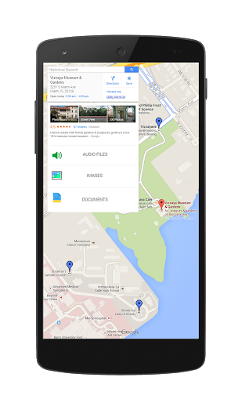 | 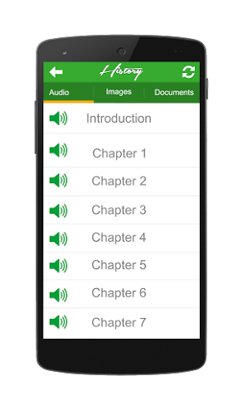
Figure 6.5.1 History App Mockup Historical Site Marking Interface | Figure 6.5.2 History App Mockup Data Files Interface
 | 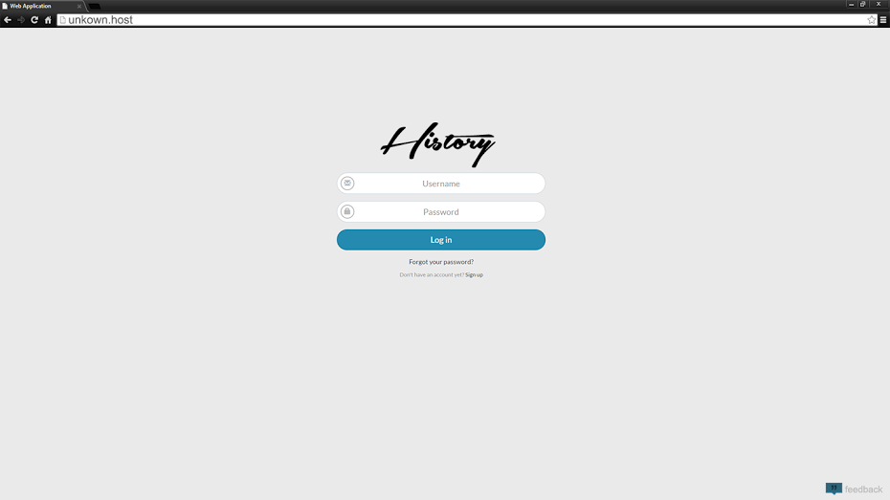
Figure 6.5.3 History App Splash Screen Interface | Figure 6.5.4 History App Web Application Login Screen Interface
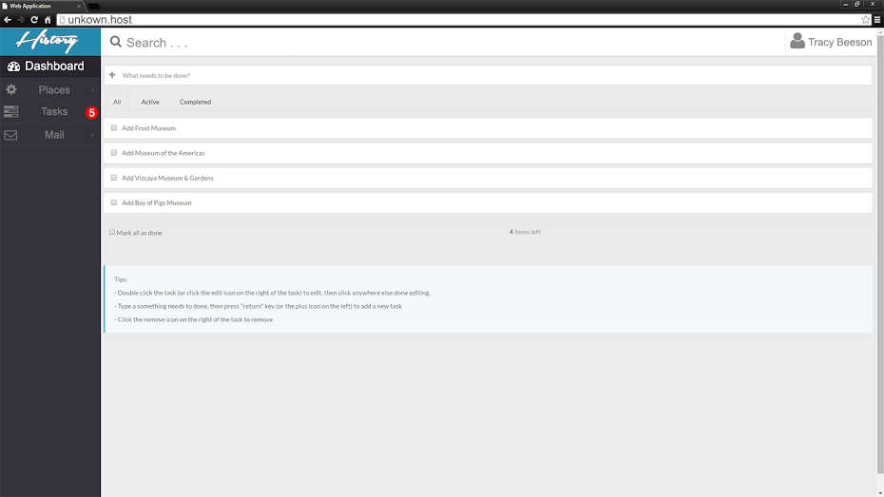
Figure 6.5.5 History App Web Application Admin Task List

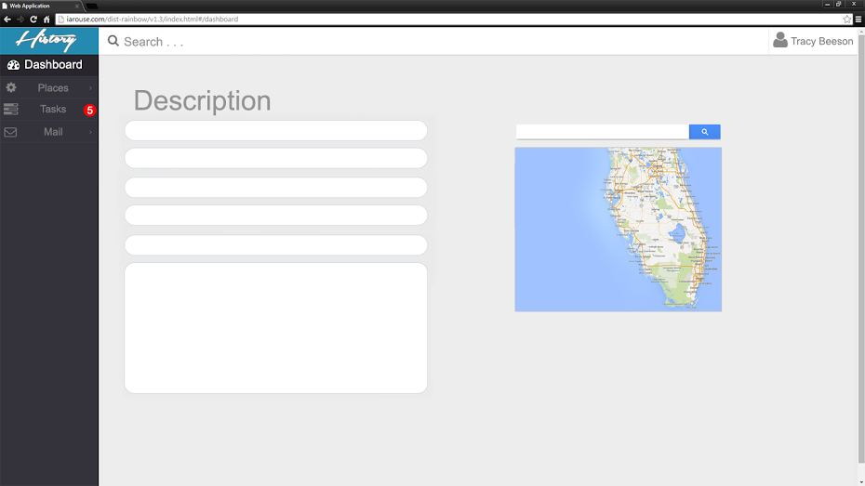
Figure 6.5.6 History App Web Application Admin Add Content
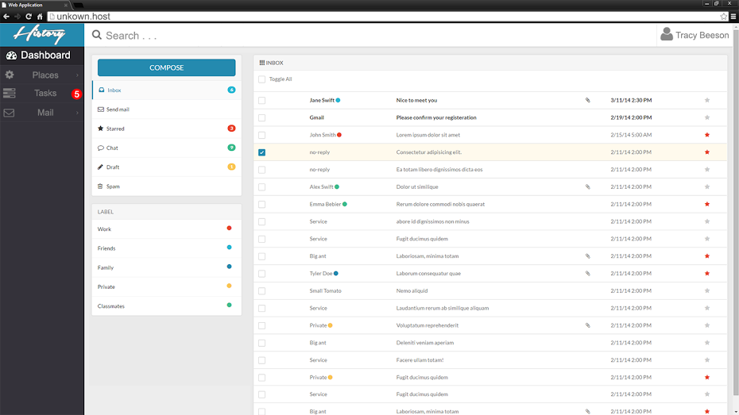
Figure 6.5.7 History App Web Application Admin Email Accessibility

Appendix F
This appendix includes all documented group meetings diary. Each diary consist of partners that arrived for the meeting, date and time, the agenda, a discussion of each individual's task and an overview of what was accomplished.

MINUTES
Meeting Date 9/3/2014
Time 6:15 PM
Meeting location JCCL in ECS
Meeting called by Yesenia Yser
Type of meeting Requirement/Analysis

Facilitator Yesenia Yser
Note Taker Ariel Diaz
Timekeeper Ariel Diaz

Attendees
Tracy Beeson
Ariel Diaz
Yesenia Yser

AGENDA TOPICS
Time allotted 1 hour 25 minutes
Agenda topic Requirement Analysis

Discussion:
Tracy was asked questions regarding the purpose and scope of the project. The project would not be based on an already existing application, meaning that it is to be built from scratch. The platform chosen to host the app is Android, however, a web application is to be created to manage the content to be displayed in the Android app. Content is to be added manually by the site admins. Yesenia and I are not expected to provide content for the application. Tracy wants an Android application that uses Google Maps to display historical items such as pieces of writing, images and sounds in specific locations in the map. A tour functionality is to be added. This would allow the users to follow a route which will provide them with information about historical events and places in the vicinity. The main user base is composed by tourists and historical societies/museums. Although in the future the app would expand to accommodate for professors by providing a way for them to peer review the existing historical items. Tracy plans to earn money through the application by enforcing a user subscription fee for those that would like to download the historical content being shown. We are expected to implement the database, data access, server file storage, android app and admin web app.
Conclusion:
-New application.
-Platform: Android and Web Application.
-Required Functionalities:
-Admins can manage content using the web app.
-Android app users can view historical items in the map
-Android app users can read/view/listen to the items pertaining to a historical event/location.
MINUTES
Meeting Date 9/6/2014
Time 12:30PM
Meeting location Google Hangouts
Meeting called by Ariel Diaz
Type of meeting Current Progress

Facilitator Ariel Diaz
Note Taker Yesenia Yser
Timekeeper Ariel Diaz

Attendees
Ariel Diaz
Yesenia Yser

AGENDA TOPICS
Time allotted: 25 minutes
Agenda topic Stand Up

Discussion:
Ariel Diaz has been working on the mock up interfaces for the History App, both Android and Web application. Yesenia Yser has been working on the Documentation, setting up the formatting of the document, working on milestones and a breakdown of workload, including the GANNT Chart. Trello has been updated with current tasks both members need to accomplish, from Documentation, Project environment, Web, and Android. Yesenia has also contacted the Mentor with the information to setup Trello and Github account. Features/ Use Case document has been created on the Google drive shared folder, split with Web and Android features and questions to be discussed later. Documentation was split already and identified on Trello. We will re-meet at 6:30PM to discuss the features and split the Use cases.
Conclusion:
-Re-meeting at 6pm for updates on current progress, regroup, and split the discuss Use cases
-Brainstorm Functional Requirements
-Ariel will create the Mock up Interfaces for the Web application
-Split the documentation -- See Trello “Documentation: First Draft - SRD” in Checklist, each of us placed name next to the section we wish to complete
-Split the Feasibility Study Documentation -- See Trellow “Documentation: First Draft -- FS” In checklist, each of us placed the name next to the section we wish to complete.
-Contacted Mentor for Trello and Github account creation
MINUTES
Meeting Date 9/7/2014
Time 11:30PM
Meeting location Google Hangouts
Meeting called by Ariel Diaz
Type of meeting Current Progress

Facilitator Ariel Diaz
Note Taker Yesenia Yser
Timekeeper Ariel Diaz

Attendees
Ariel Diaz
Yesenia Yser

AGENDA TOPICS
Time allotted: 25 minutes
Agenda topic Stand Up

Discussion:
Yesenia Yser has been working on the sections of the Software Requirement Document (SRD). Ariel Diaz has finalized the mockups for both the Android Application and the Web Application. A list of features has been created and work on the use cases has begun.

Conclusion:
-Continued progress on the SRD.
-Design mockups have been finished.
-Use cases are being documented

References

